caXchange All Hands Meeting

Meeting Notes
Session Information | Date: February 5, 2008  Time: 1:00 – 2:00 ET  Facilitator: Michael Holck  Scribe: David Dorman
Executive Summary | The purpose of this meeting was to provide a brief overview and demonstration of the Cancer Center Hub Client (CCHC) application to stimulate feedback and enhancement requirements from the virtual meeting participants.
Key Outcomes/ Decisions | - Provided participants with a high-level description and explanation of the Cancer Center Hub Client (CCHC) application and requested recommendations for potential functional and interface requirements.  - Answered several relevant questions concerning the application’s functions and interface with other entities to the satisfaction of the participants  - Received several excellent recommendations that will support the application’s usability  - Identified need to review all past feedback on project products, convert to requirements, and prioritize (high/low value) for next release
Key Discussion | Cancer Center Hub Client (CCHC)  - The CCHC is responsible for producing laboratory data in an HL7v3 CT Periodic Observation Lab Message.  - It has transformation and lookup services to aid in the building of this message.  - Is used to load laboratory data into CTODS and by extension CCTS 1.0.  - Cancer Center Hub Client (CCHC) is installed at a cancer center.  - Lab Data is provided to the client in either comma separated values (CSV) format or HL7v2 format. User can load an individual file or setup a directory for polling. Input format must be mapped to HL7v3 message once.  - Mapping is done using caAdapter. It is the responsibility of the user to understand each systems terms/data elements to enable proper match. Familiarity with the data structure and format of both systems is important. There are no data validation rules.  - CCHC transforms data into an HL7v3 CT Periodic Observation Lab Message. If a cancer center can produce an HL7v3 CT Periodic Observation Lab Message directly from their lab system this will work as well. This can be implemented locally or configured to support a service.  - CCHC looks up the study information for the lab message using the patient MRN. Any system that implements the study lookup grid service can be used. CTODS is currently used.  - CCHC submits the completed HL7v3 CT Lab Message to caXchange for storage in CTODS (Clinical Trial Object Data System.  - CCHC Dependencies: Source data (CSV or HL7v2) Mapped to HL7v3 CT Periodic Observation Lab format. Mapping file stored on the client machine. Study Lookup grid service installed. CTODS Lab Viewer provides but could be provided by other applications or systems. caXchange Hub installed and configured to receive and route the lab message. Dorian installed and configured for authenticating users and providing grid credentials. For secure services.  - Simple functional architecture:  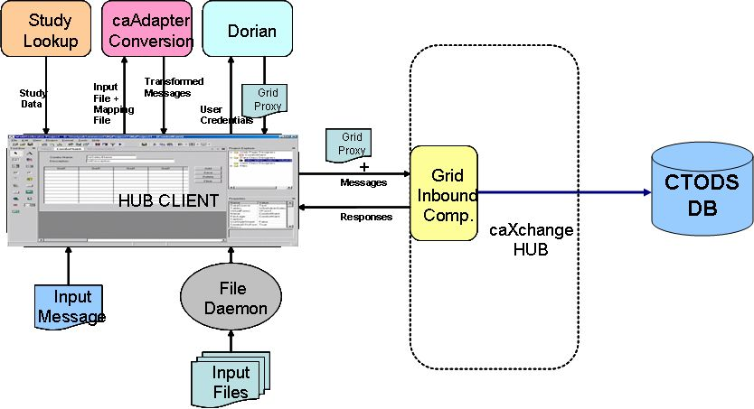  - Hub Client Interface, Main Tab  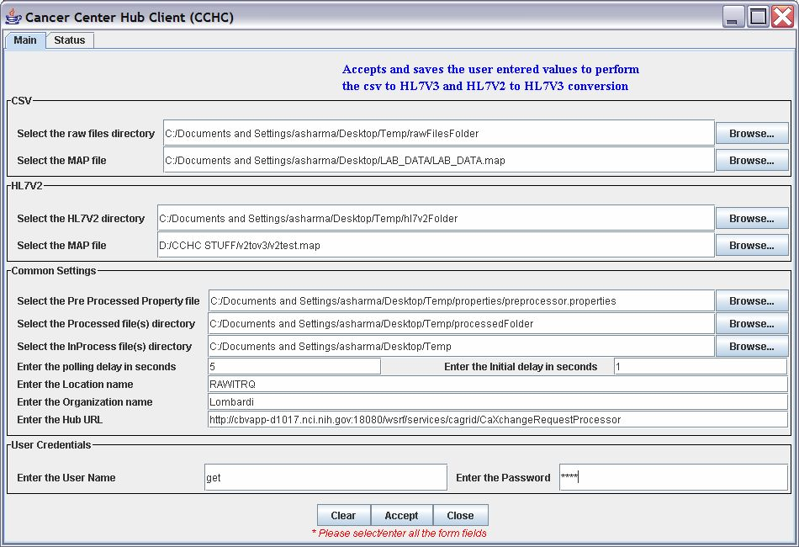  - Hub Client supports CSV and HL7v2 data format. Processes and saves data in three stages, which support user review and error management before a final product is created. Application saves ‘last settings’ locally, so there is no need to pre-configure name/organization information.  - Participants related that the applications interface was simple and generally intuitive. Recommendations include: Add a ‘help’ feature near each interface element to help explain each stage/element to the user. The ‘help’ feature can be instituted with some type of help button near each interface element or maybe some type of mouse over/popup feature.  - Hub Client Interface, Status Tab  - The status window visually displays the data build and save process to the user. The window also displays a log of the process. Errors display in the log and a popup element over the main interface.  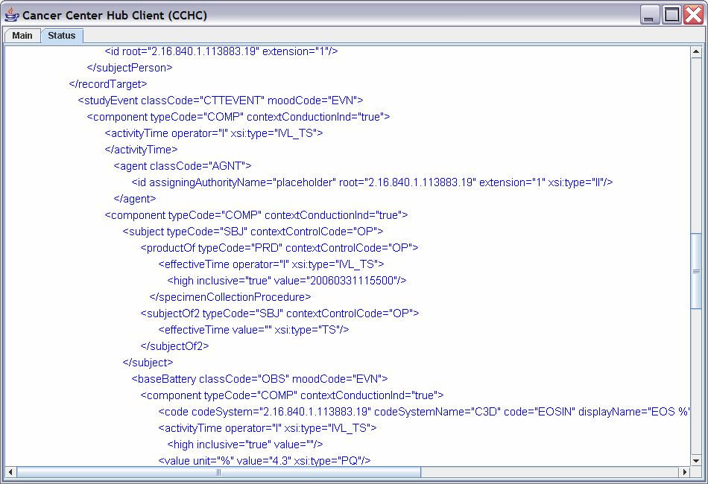  - Recommendations include: Provide a logs tab that displays a menu of types of logs for the user to view. Each process should have a separate and distinct log view relevant to its function (i.e. date/time submission, errors, login, picked up, sent, processed, time stamps).  - Once data is loaded into CTODS database (stores laboratory data), it is available from Lab Viewer. The data can then also be sent to a CDMS system (i.e. C3D). The system can be deployed locally or federated. Initially it will most likely be a locally managed capability. It was recognized that local management will be easier to support and maintain.
Issues
  Issue ID | Description
  1 | - None
Action Items
  Item | Assigned To | Due Date
Next Steps | All feedback received to date will be compiled and made available for review during the next meeting. The feedback will each be considered for future requirements and prioritized accordingly. The next meeting will be held on Feb. 19th, 2008 at 1:00 ET.
Attendees
   | Last Name | First Name | Affiliation | Email
   | Holck | Michael | ScenPro | mholck@scenpro.com
   | McCurry | Bill | ScenPro | bmccurry@scenpro.com
   | Patel | Kalpesh | Ekagra
   | Cooper | Mary
   | Lanese | Bob | Case Western
   | Mungal | Salvatore
   | Schad | Peter | NCI
   | Evans | Maegan
   | Tran | Tu
   | Deguilian | Beth
   | Wolf | Heather
   | Shahmalak | Tasneem
   | Hooping | Dan
   | Agarwal | Pankaj
   | Budd | Ryan

